# Michael Chillemi

# 06/24/2023

# CS 590 - Algorithms

# M5.B2: Module 5 Hash Tables Creativity Exercises

Problem 6.7.15

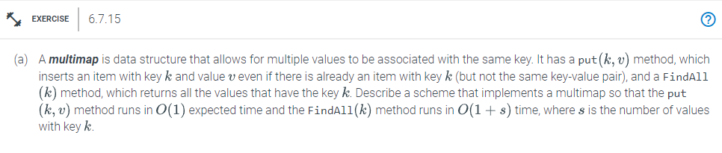

Answer:

We can use an unordered map with an int key and a vector of int values to fulfill our requirements within the time limits provided. In the Put(k,v) function. When attempting to insert a value against a specific key value, we search the unordered_map for the key's associated vector before inserting the value. Inserting a new element into a vector and searching a map both happen in O(1). The entire time is therefore O(1). The Findall(k) function traverses the entire vector after finding the key's vector in the unordered_map in O(1) time. Say there are s values associated with a specific key. As a result, it will take O(s) to traverse the vector . The total time is therefore O(1+s).

Below I have provided code to go with the explanation above.

unordered_map<int,vector<int>> multiMap; //declaration of the Data Structure

void put(int key,int value)

{

**Operation = O(1) time **

multiMap[key].push_back(value);

}

void Findall(int key)

{

**Operation = O(n), where n is the number of values against a particular key**

for(int ele:map[key]){

cout<<ele<<endl;

}

}